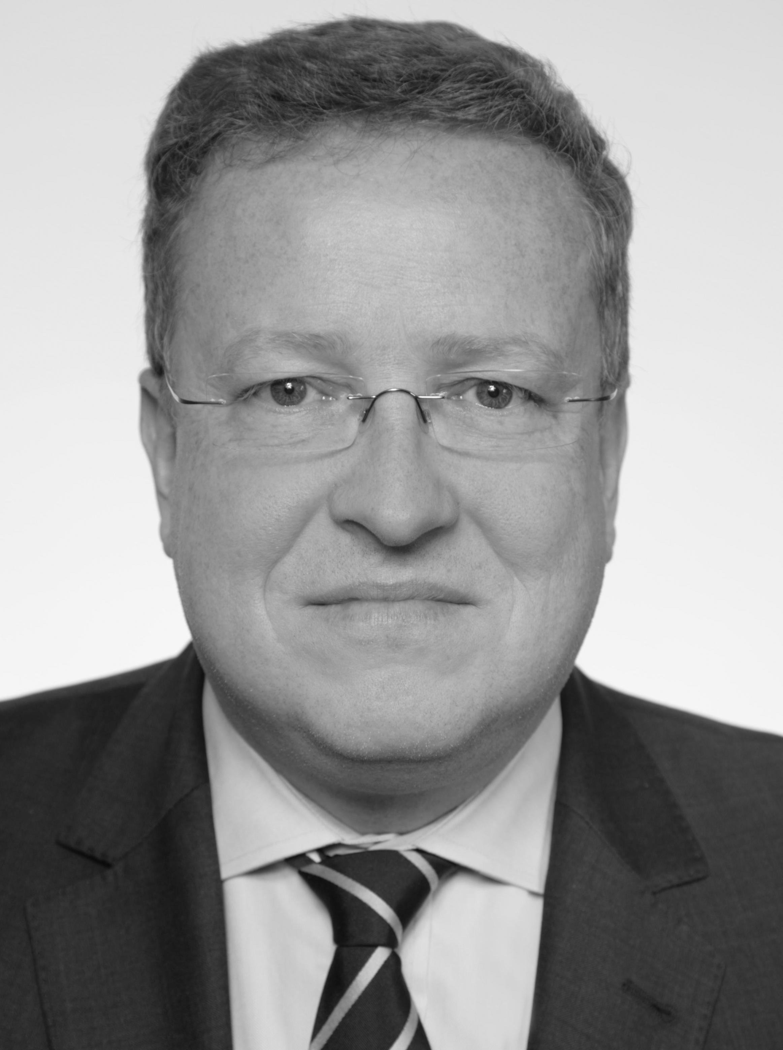
CV Mike Albien
Management Summary

Personal Information | - Year of birth 1963  - Interim management, project management, transition and transformation, project management, data center migration and roll-out, Outscourcing, process analysis and modeling, conflict management, lecturer, coaching  - Project management trainer  - foreign assignment in India, England, Ireland, Italy, France, Sweden, Spain, Slovakia, Czech Republic, Bulgaria.
Education and Certifications | - Mechanical Engineneer  - PMI, ITIL, REFA, Scrum
Relevant Interims and Project Experience | - SAP in Walldorf, Advanced-Project-Management, Project Management Trainer  - VHV in Hannover, Interims Manager IT-Operation and IT-Outsourcing  - Volkswagen in Wolfsburg, Project Management Consulting  - LBBW in Stuttgart, Consulting IT-Outsourcing Management  - 1&1 Internet AG in Karlsruhe, Support for leadership change, an interim manager  - BayernLB in Munich, data center migration, Project manager  - WestLB in Duesseldorf, Global Rollout Infrastructure, project manager  - vodafone in Duesseldorf, disaster recovery planning, project manager  - e.on-IS in Hannover, infrastructure project, project manager  - TUI-InfoTEC GmbH in Hannover, Head of UNIX&Middleware, interims manager (IT-Outsourcing)  - AIRBUS Hamburg, design and conduct of a documentation team, project manager  - ROCHE Mannheim/Basel/Madrid, project manager DC-migration in Co-location, analyze, rollout and planning  - Postbank Systems Bonn/Frankfurt, T&T program manager DC-disentanglement ad for Postbank Carve Out, Workplace Disentanglement  - SEICO in Rotenburg (W), project manager, ERP-implementation, process analysis, planning and rollout
Core Competencies | - Interims and project management know-kow, communication skills,
Personal Strengths | - analytically, objectively, motivating, pragmatic, strong contact

Consultant Profile Mike Albien
 | Personal Data
 | Name |  |  | Mike Albien
 | Address |  |  | Malvenstr. 48, 27729 Hambergen (near of Bremen)
 | Email-Address |  |  | project@albien.net
 | Telephone |  |  | +49 174 987 11 78
 | Mobile |  |  | +49 174 987 11 78
 | Year of birth |  |  | 1963
 | Nationality |  |  | German
 | Family status |  |  | Married, three children
 | Career
 | Education, University |  | 1988 Mechanical Engineer
 | Occupational milestones |  | 2010 TCI, (Associate) Partner , Competence- area(s): Banking, insurance, aerospace (Airbus), telecommunications, software development, IT services, energy, tourism, automotive, health & pharma  2016, SEICO, Rotenburg (W), Project Manager, ERP-Implementaion  2015, Postbank, Bonn/Frankfurt, Program Manager, DC-Disentanglement  2015, ROCHE, Mannheim, Basel, Madrid, Project Manager RZ-Migration  2014, KfW, Berlin und Frankfurt, Veränderungs-Manager 2014, NordLB, Hanover, Project Manager, Data Center Migration  2014, HASPA, Hamburg, Project Manager  2013, LBBW, Stuttgart, Management IT-Outsourcing  2013, VW, Wolfsburg, Project Manager  2012, VHV, Hannover, Interims Manager IT-Operations  2011, WestLB, Duesseldorf , Project Manager (Global Infrastructure Rollout)  2010, Talanx/HDI-Gerling, Hannover/Cologne, transition manager  2010, HypeRealEstate, Stuttgart, project manager datacenter migration  2009, SAP, Walldorf, Projectmanagement-trainer (Advanced Project Management), (ongoing engagement)  2009, 1&1 united internet, Karlsruhe, Interimsmanager/Business consult  2008, BayernLB/FI-TS, Munich, project manager datacenter migration  2007, AMB-Generali, Hamburg/Aachen, multi-project manager  2007, vodafone, Duesseldorf/Ratingen, project manager  2006, eon-IT, Hannover, project manager datacenter migration  2005, TUI-InfoTEC, Hannover, interims manager, IT-Operation  2003-2005, AIRBUS, Hamburg/Bremen/Toulouse, project manager  2002-2003 IUB, Bremen, networkmanager, project manager  2001 vodafone, Duesseldorf, project manager, IT-security  1992-2000 AIRBUS, Hamburg/Bremen/Tououse, project leader, IT-security, UNIX, data center infrastructure
 | Skills
 | Languages |  | German native  English fluent, conversation, advanced
 | Certificates |  | PMP  ITIL Foundation
 | Methods |  | PMI, Risk analysis, ISO 20000, 27000, MaRisk (§44 KWG, §25a KWG, Ma Risk AT 7.2, §5 BuDaSG), Srcum, KanBan, ScrumBan,  ROCHE AG – Complete set of mandatory trainings GxP, SoP, in 2015
 | Technical Skills |  | ITIL , PMI, MS-Project, Visio, MS-Office, MS-Sharepoint
Industry Skills
 |  | - Banking  - Insurance  - Aerospace (Airbus)  - Telecommunications  - Software development |  |  | - IT service  - Engergy  - Tourism  - Automotive  - Pharma & Medical

Projects (excerpt)

2011-2016 | Project and Program management and Interims management  Project management and coaching in initiating, planning and implementation of international infrastructure roll-outs and pre-study-exchange SW in internationally active financial firms. Provider management and contract management. IT-Outsourcing.
2010-2011 | Transition management  Transition Transformation Manager, Interim Manager, Pre-study, planning and implementation of data center migration, analysis of the data center facilities, contracting / contract review (legally / professionally), development / optimization CMO / FMO CLA​​'s international insurance company.
2009 | Interims management  Interim Manager support for change in leadership. Staff functions, optimizing structures and processes. Analysis, definition and implementation of operational processes. Implementation of procedures and standards. Initiation of change processes. Teamwork / cooperation between groups to promote conflict-laden. Development and provision of KPI's. Support the Head of Development & IT operation in a major Internet and communications companies.
2008 | Projectmanagement Datacenter Migration  DC-migration of a state bank. State analysis of banking applications and communications, planning and designing the data center migration and its facilities. Transition Manager for an IT provider change in the entertainment and electronics industries.
2007 | Project management  Project management for an international communications company, planning and disaster recovery data center in Europe. Evaluation and selection of suitable facilities. Project manager for system software version and release upgrades multi-project management project management for an international insurance company
1992 – 2007 | Project- und Interims management and consultancy projects  Project and interim management, implementation of ITIL-based processes, infrastructure and facility planning, data center design and documentation, training and coaching in leadership environment, implementation of processes and implementation of manufacturing documentation, planning and implementation of security in network and communications environment a large European Aeronautic Defence and space Company.
2009 – now | SAP – Project management trainer  Advanced Project Management training based on PMI methodology using a case study: rehabilitation of an airport at full operation.

